**Springboard Data Science Career Track Guided Capstone**

**Project Report:**

**Akbanu Tleubayeva**

**February, 2021.**

**Introduction**

Big Mountain Resort is a ski resort located in Montana. It offers spectacular views of Glacier National Park and Flathead National Forest, with access to 105 trails. Every year about 350,000 people ski or snowboard at Big Mountain. It can accommodate skiers and riders of all levels and abilities. These are serviced by 11 lifts, 2 T-bars, and 1 magic carpet for novice skiers. The longest run is named Hellfire and is 3.3 miles in length. The base elevation is 4,464 ft, and the summit is 6,817 ft with a vertical drop of 2,353 ft. Big Mountain Resort has recently installed an additional chair lift to help increase the distribution of visitors across the mountain. This additional chair increases their operating costs by $1,540,000 this season. The resort's pricing strategy has been to charge a premium above the average price of resorts in its market segment. They know there are limitations to this approach. There's a suspicion that Big Mountain is not capitalizing on its facilities as much as it could. Basing their pricing on just the market average does not provide the business with a good sense of how important some facilities are compared to others. This hampers investment strategy. The business wants some guidance on how to select a better value for their ticket price. They are also considering a number of changes that they hope will either cut costs without undermining the ticket price or will support an even higher ticket price. The primary task is to predict the Ticket Price Big Mountain Resort can charge its customers considering the features it offers and its market segment. Present ticket price is $81.00.

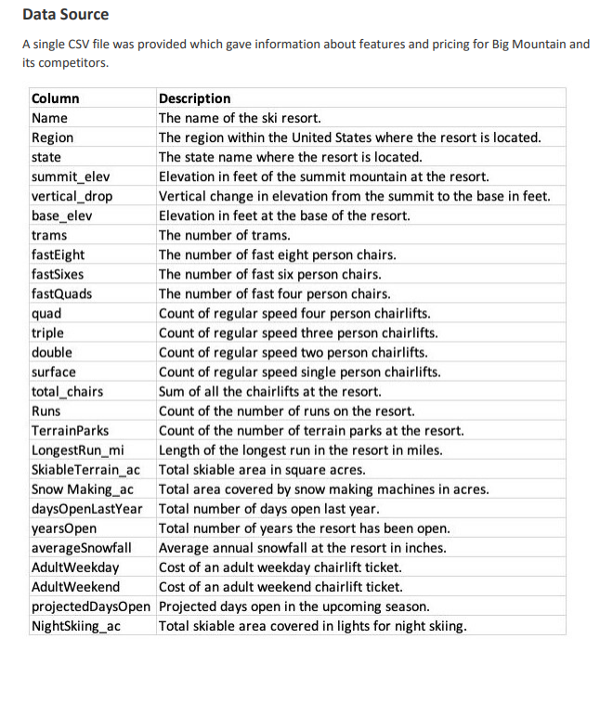

**Modelling**

Following features came up as important in our analysis:

vertical_drop

Snow Making_ac

total_chairs

fastQuads

Runs

LongestRun_mi

trams

SkiableTerrain_ac

Here are some charts which represent these features and the relative position of Big Mountain Resort.

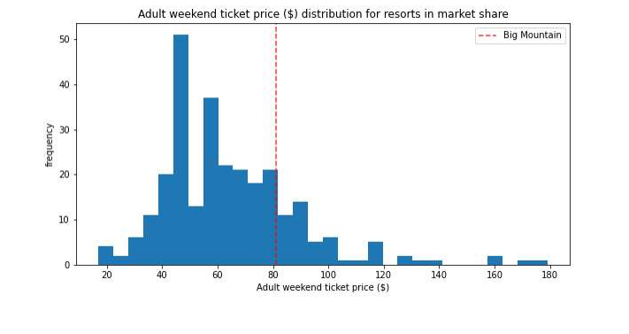

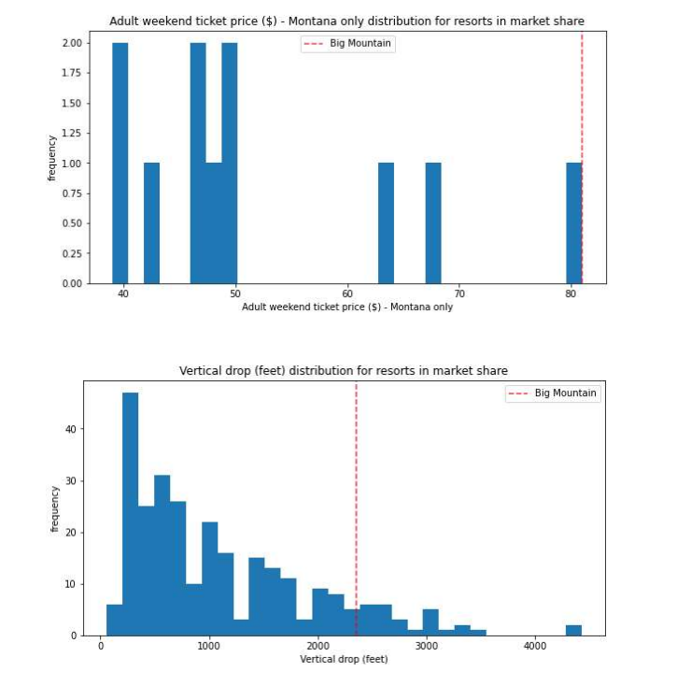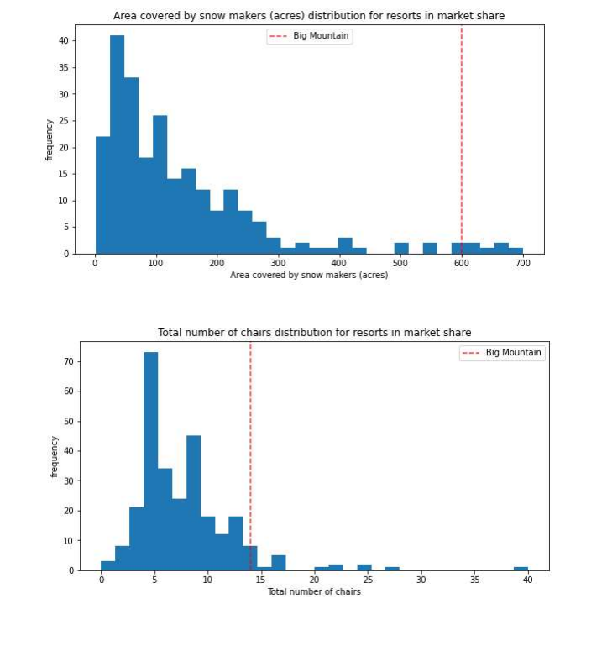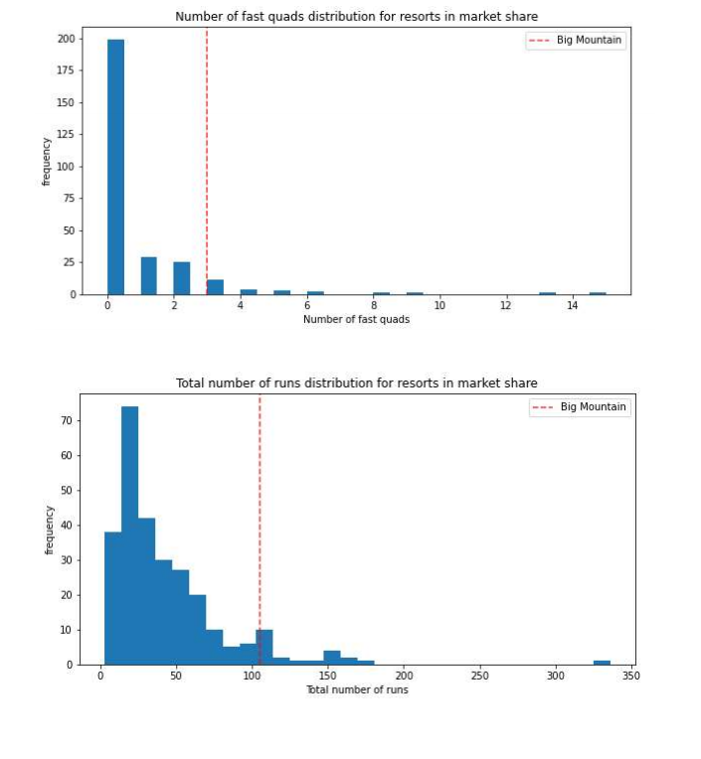

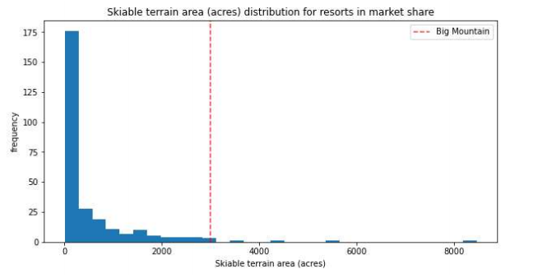

**Summary**

**Other Analysis**

We also investigated various proposals to increase revenue (ticket price).

1. Closing top 10 unused runs. The model says closing one run makes no difference. Closing 2 and 3 successively reduces support for ticket price and so revenue. If Big Mountain closes down 3 runs, it seems they may as well close down 4 or 5 as there's no further loss in ticket price. Increasing the closures down to 6 or more leads to a large drop.

2. Increase vertical drop by 150 feet and install an additional chair lift. In this scenario, Big Mountain is adding a run, increasing the vertical drop by 150 feet, and installing an additional chair lift. This scenario increases support for ticket price by $1.99 and over the season this could be expected to amount to $3474638.

3. Increase vertical drop by 150 feet and install an additional chair lift and add 2 acres of snow making capability. This scenario increases support for ticket price by $1.99 and over the season this could be expected to amount to $3474638. This is similar to scenario 2 so there is no effect of adding extra 2 acres of snow making capability.

4. Increasing the longest run by 0.2 miles and guaranteeing its snow coverage by adding 4 acres of snow making capability. This scenario does not support any increase in ticket price.

**Summary**

Big Mountain exceeds in most features in its market segment. Based on this our model predicts that Big Mountain can increase price up to $95.87. The Mean absolute error is $10.39, which suggests there is room for an increase.

**Notes**

Additional data like the number of visitors in a season and the costs associated with each feature would have increased the accuracy of our model.